1. Write a program for Abstraction?

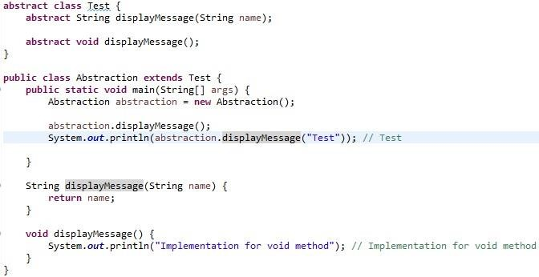

1. Write an example for Encapsulation?

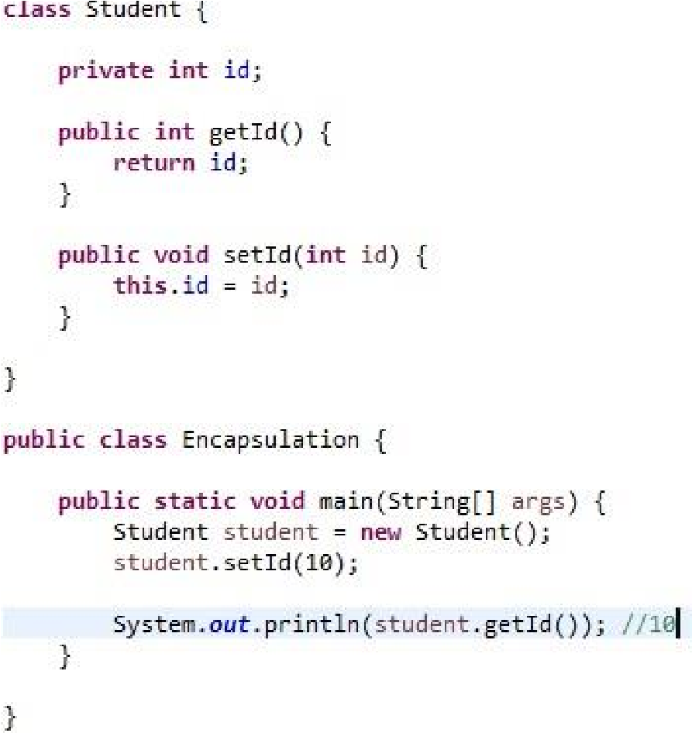

1. Write an example for Polymorphism?

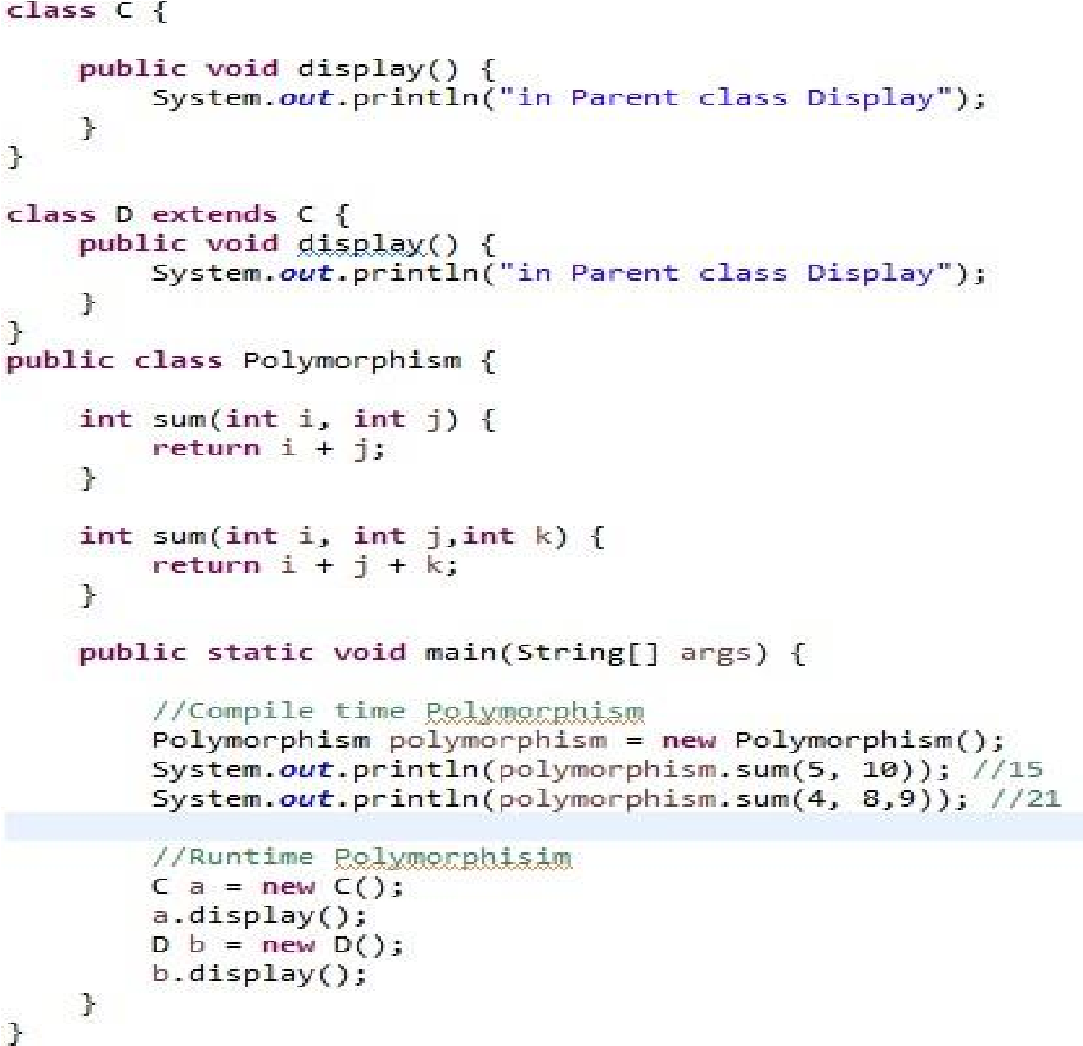

1. How to reverse a string without recursion?

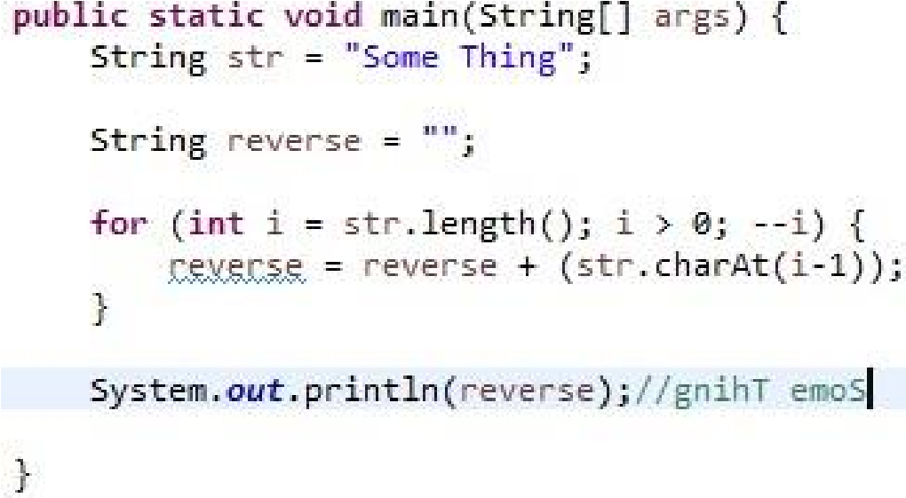

1. How to swap two Strings without using a third variable?

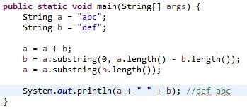

1. Write a program to reverse a number?

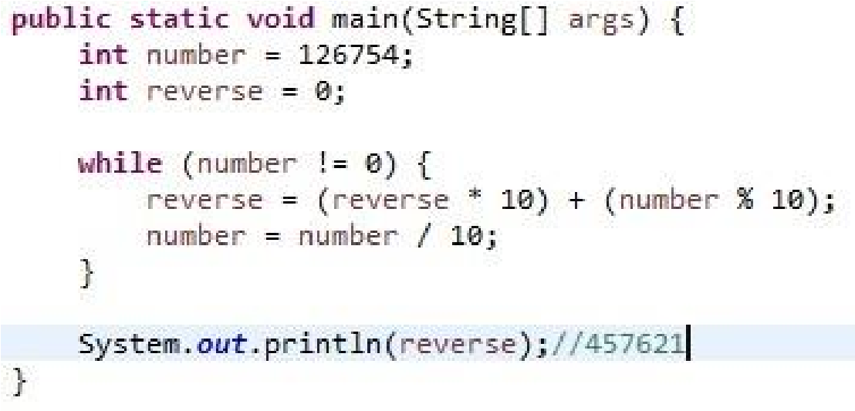

1. Write an example for Sting Sub String?

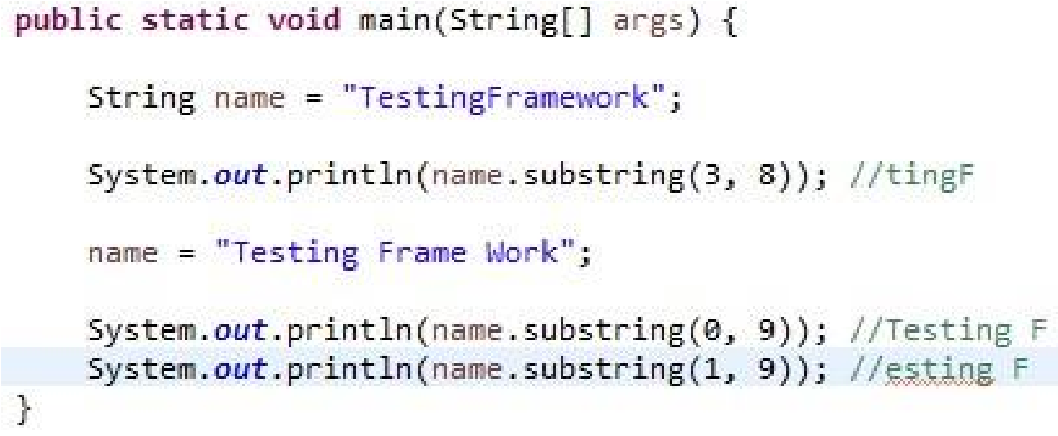

1. Write a program to check given input is palindrome or not?

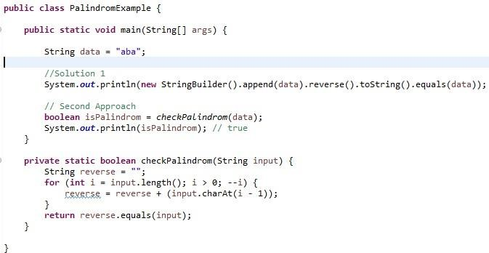

1. Write an example to know Even or Odd number?

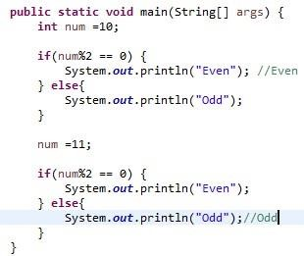

1. Write an example to know given number is prime or not?

|  |  |
| --- | --- |
| than 1 and itself. For example, 5 is prime, as only 1 and 5 divide it, whereas 6 is composite, | |
| has the divisors 2 and 3 in addition to 1 and 6. |  |

A prime number (or a prime) is a natural number greater than 1 that has no positive divisors other since it

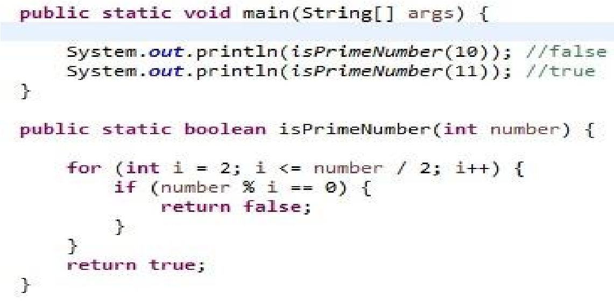

1. Given an example to get the factorial of a number?

Example: if input is 3: 3*2*1 =6

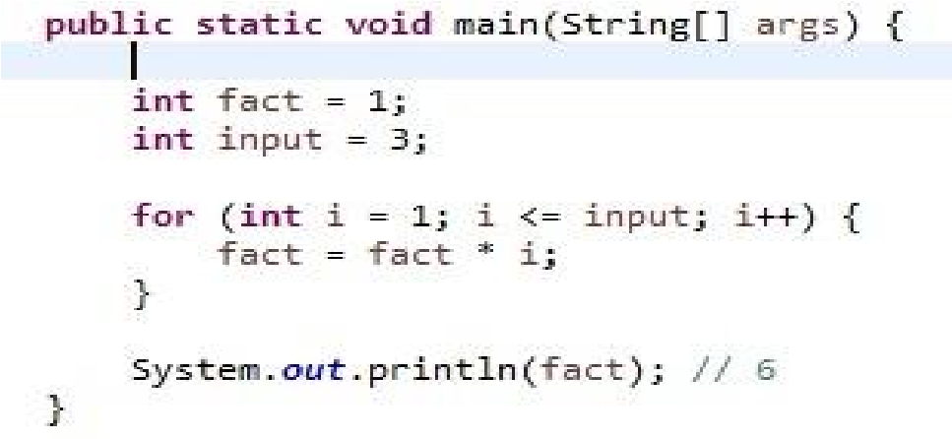

1. Write a logic to find the duplicate characters in String?

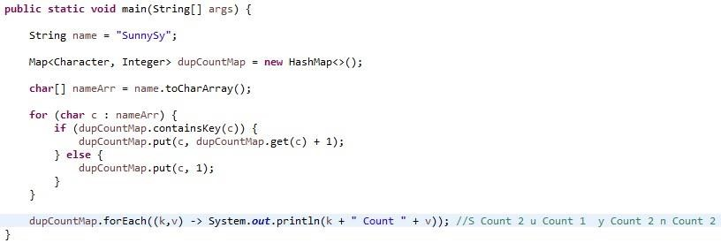

1. Write a program to check String is Anagram or not?

Two strings are called anagrams if they contain same set of characters but in different order.

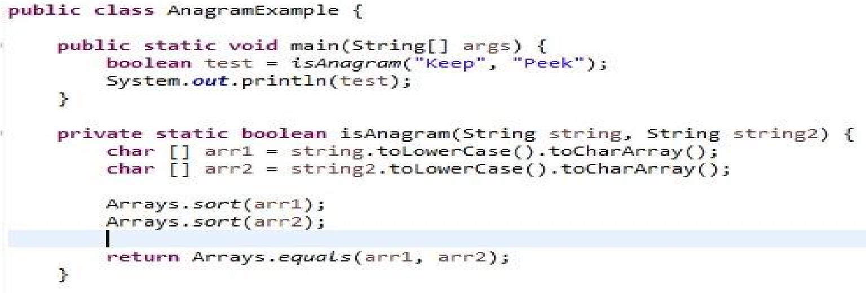

1. Write a program to found the highest repeating character in String?

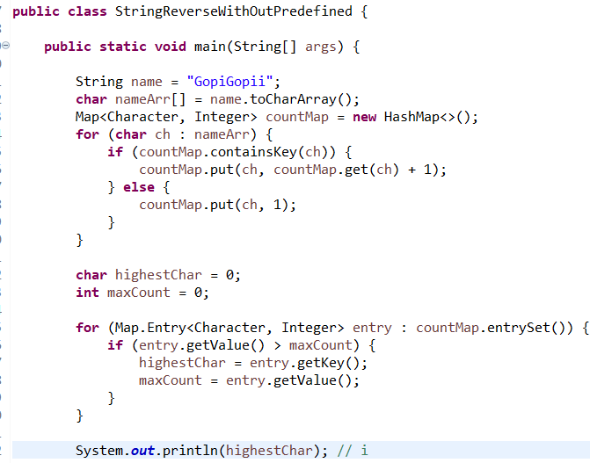

1. Write a program to print fibonacci series?

By definition, the first two numbers in the Fibonacci sequence are 0 and 1, and each subsequent number is the sum of the previous two.

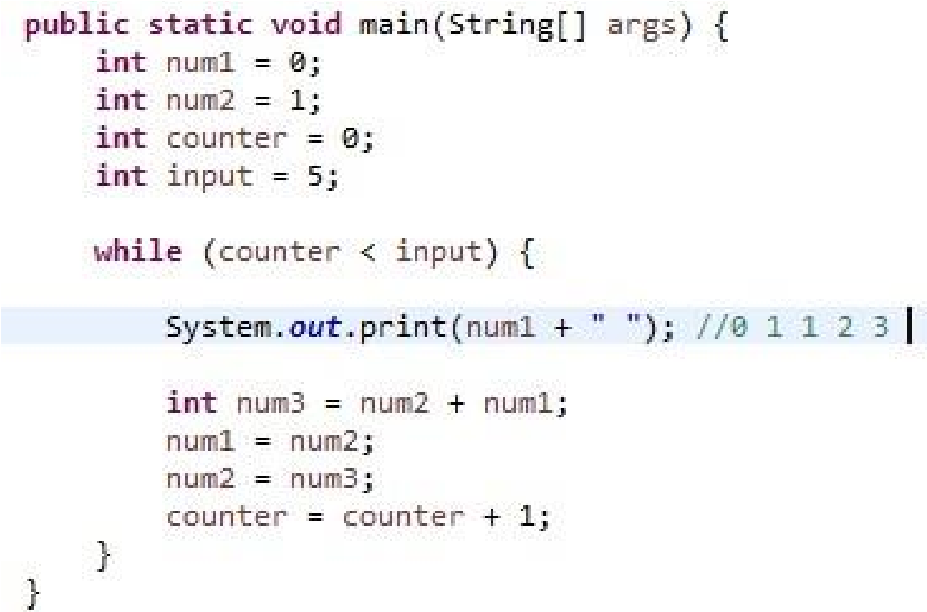

1. Write a program to print 1 to 100 and 100 to 1 numbers without loop?

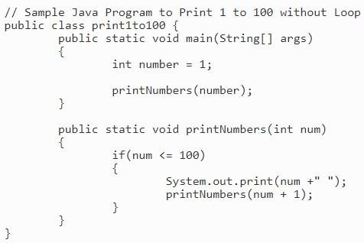

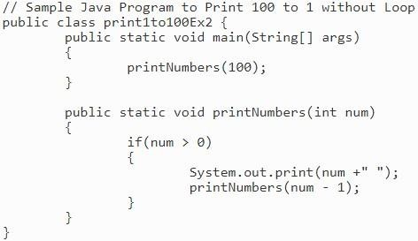

1. Write a logic to find the duplicate numbers and its count in an Array?

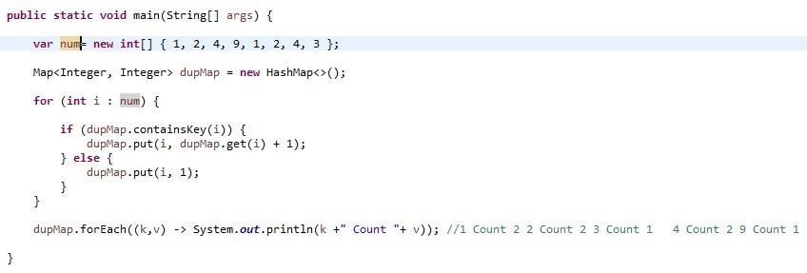

1. Write a program to shuffle the array?

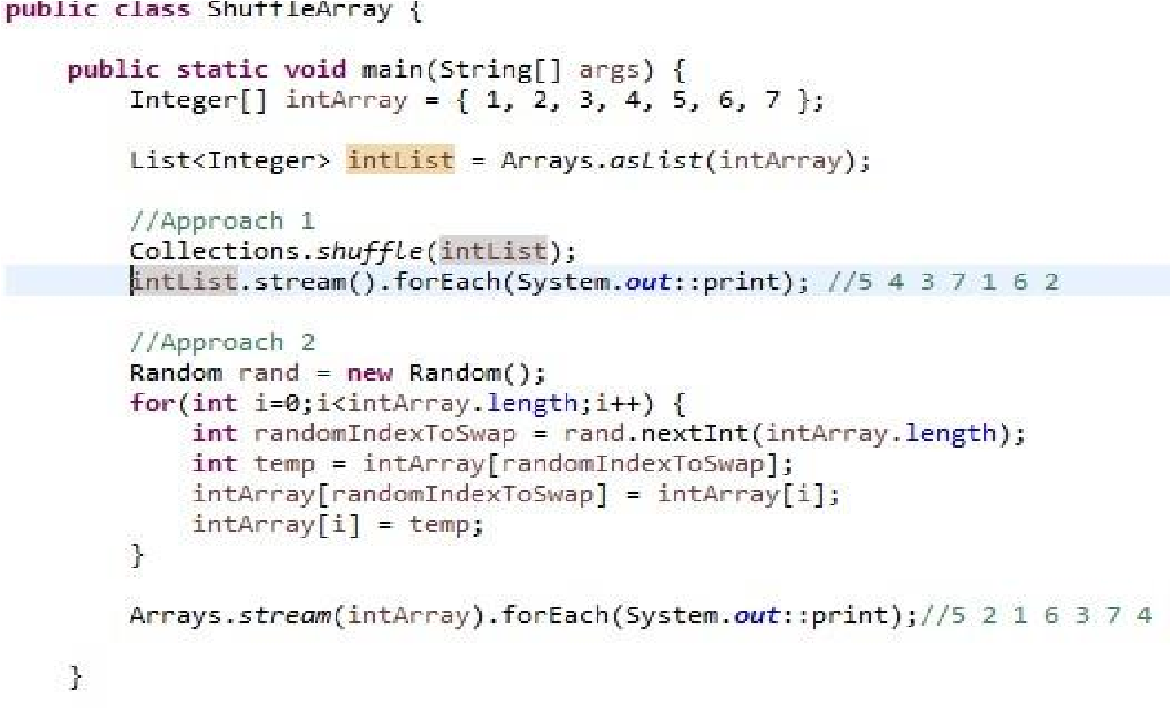

1. Write a java program to rearrange Positive & Negative Values in an Array?

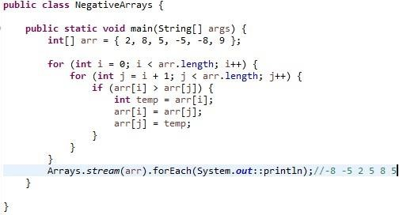

1. Prove String is immutable?

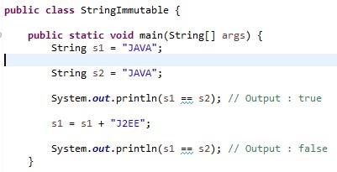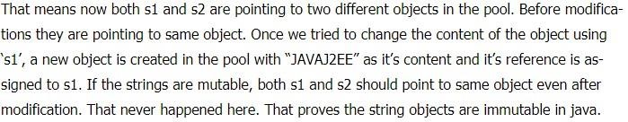

1. Write a program to find Highest and Lowest numbers in an array?

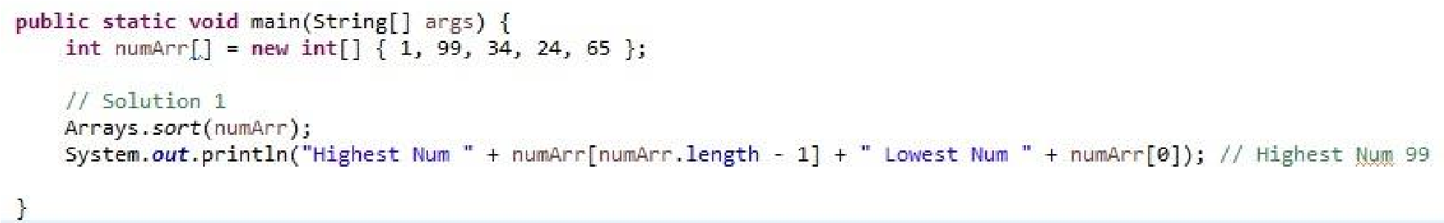

1. Give best example to compare and find common elements two arrays?

Below is the best way if we can manually compare it by writing the separate loops

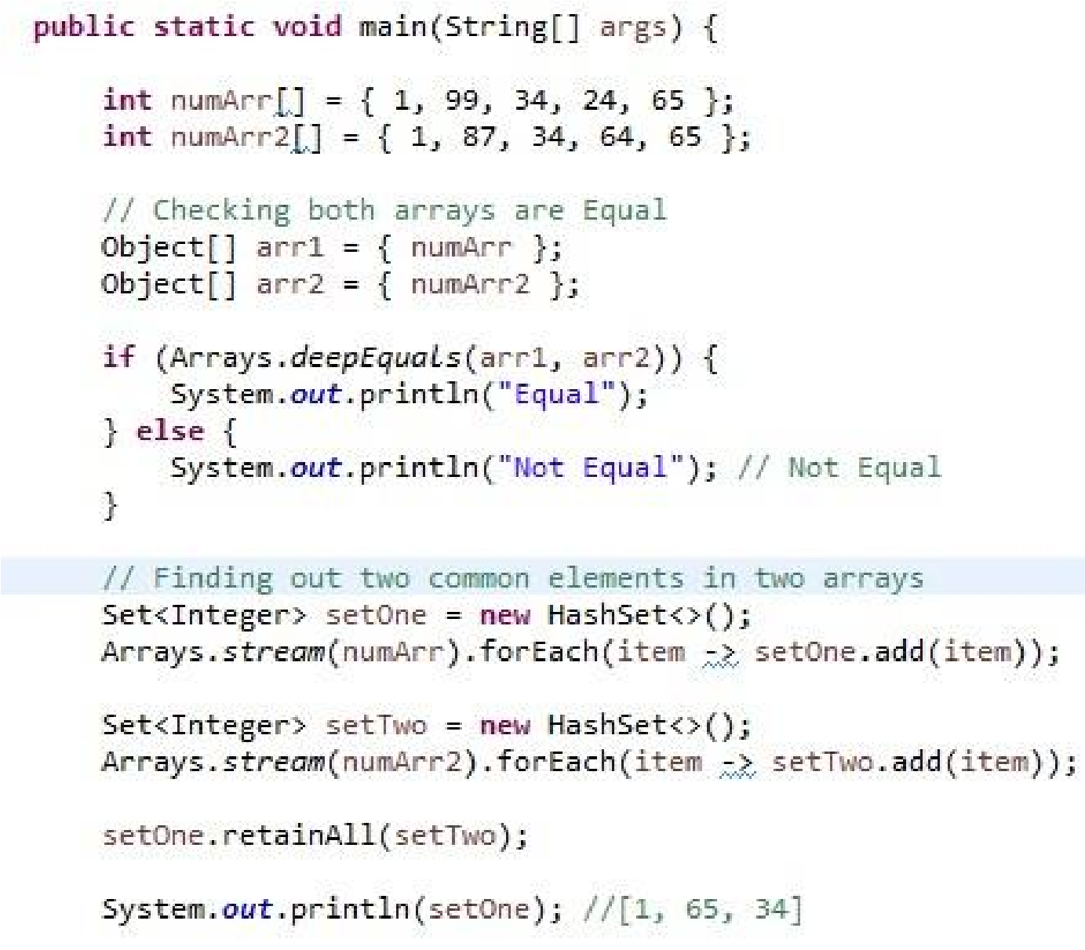

1. Write a program to remove duplicates from sorted array?

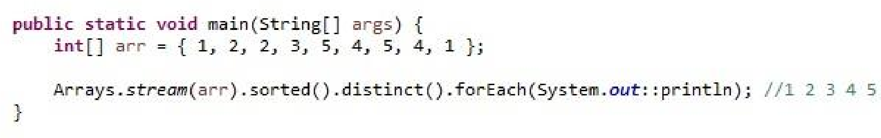

1. Write a program to convert string to number without using Integer.parseInt() method?

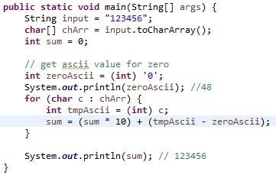

1. Write a program to create deadlock between two threads?

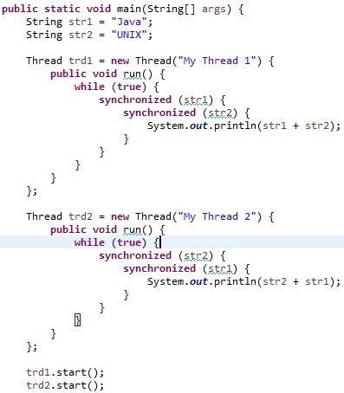

1. How to swap two numbers without using temporary variable?

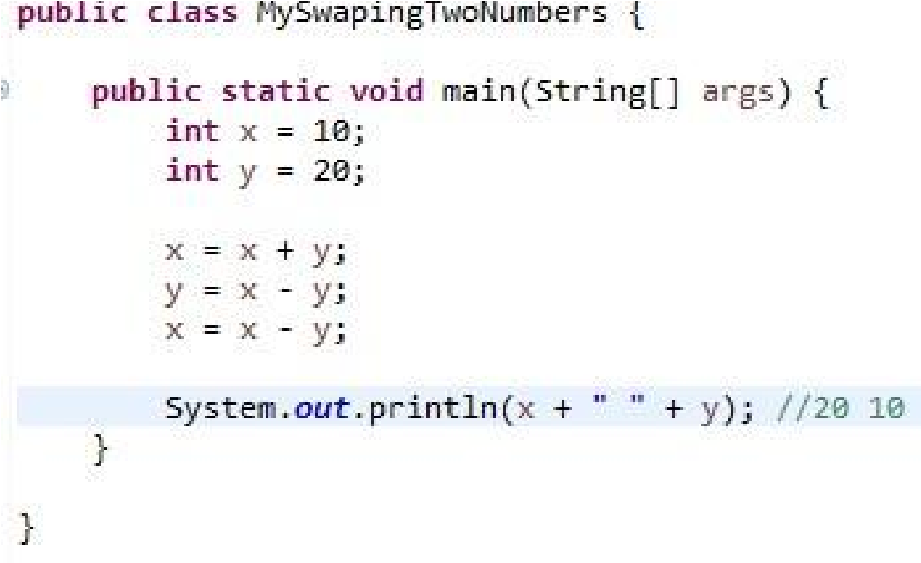

1. Write a program to implement hashcode and equals.

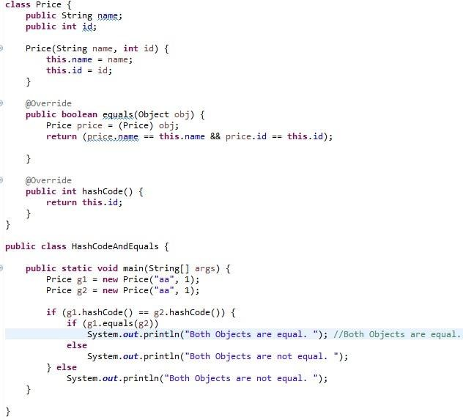

1. Give an example for Bubble Sort?

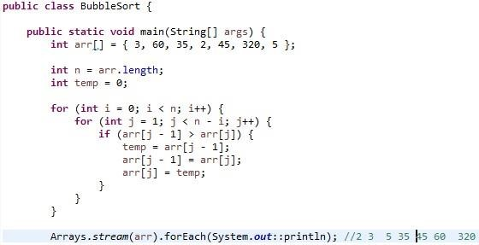

1. Give an example for Binary Search?

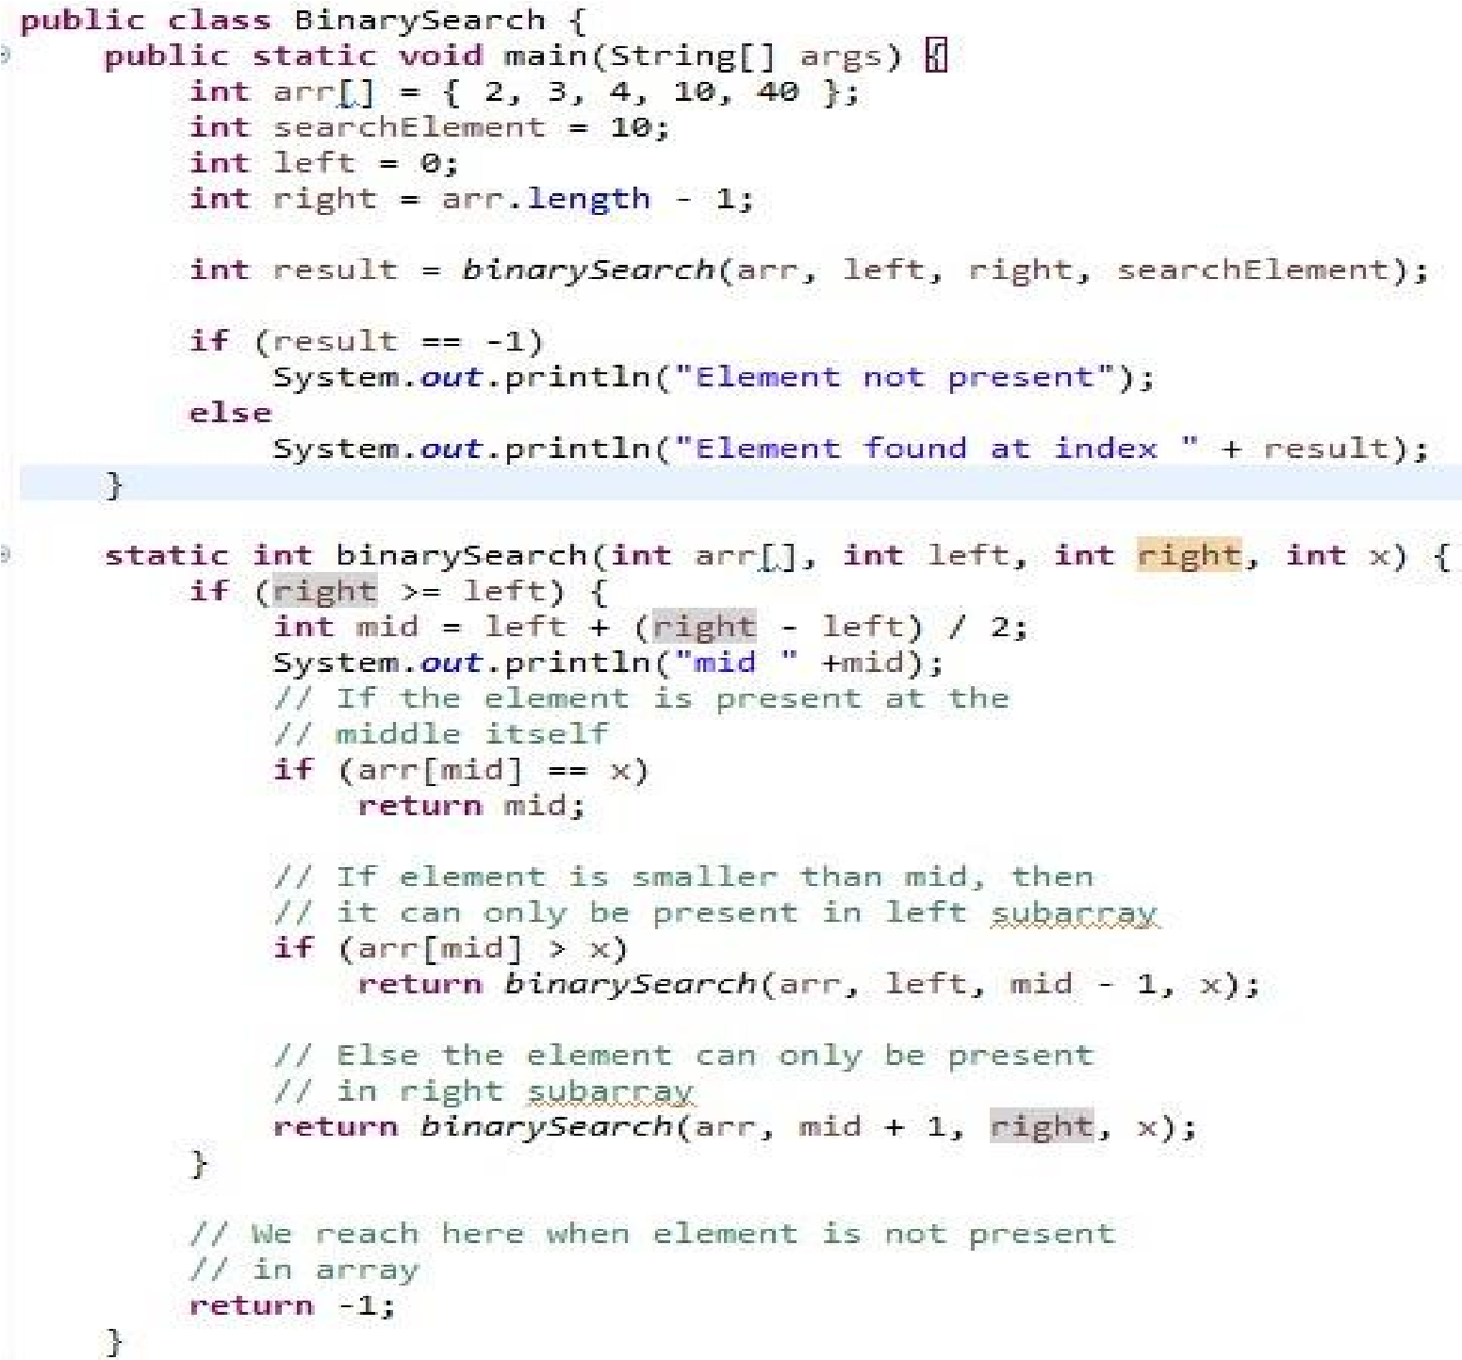

1. Write a logic remove duplicates from ArrayList without using Set or Map?

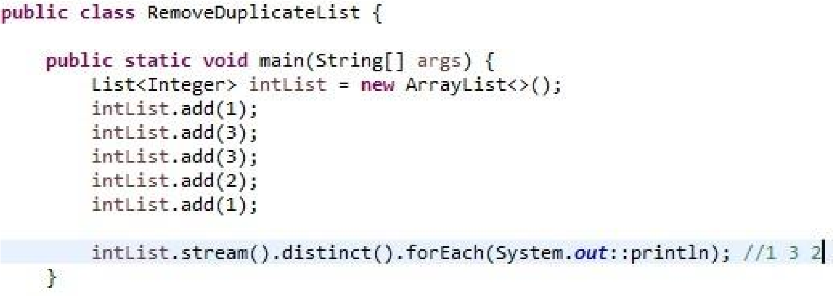

1. Write a logic to remove the duplicate objects from List?

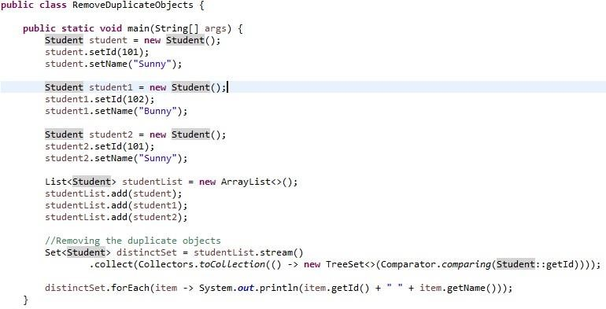

1. Given the list of employees, count number of employees with salary > 5000?

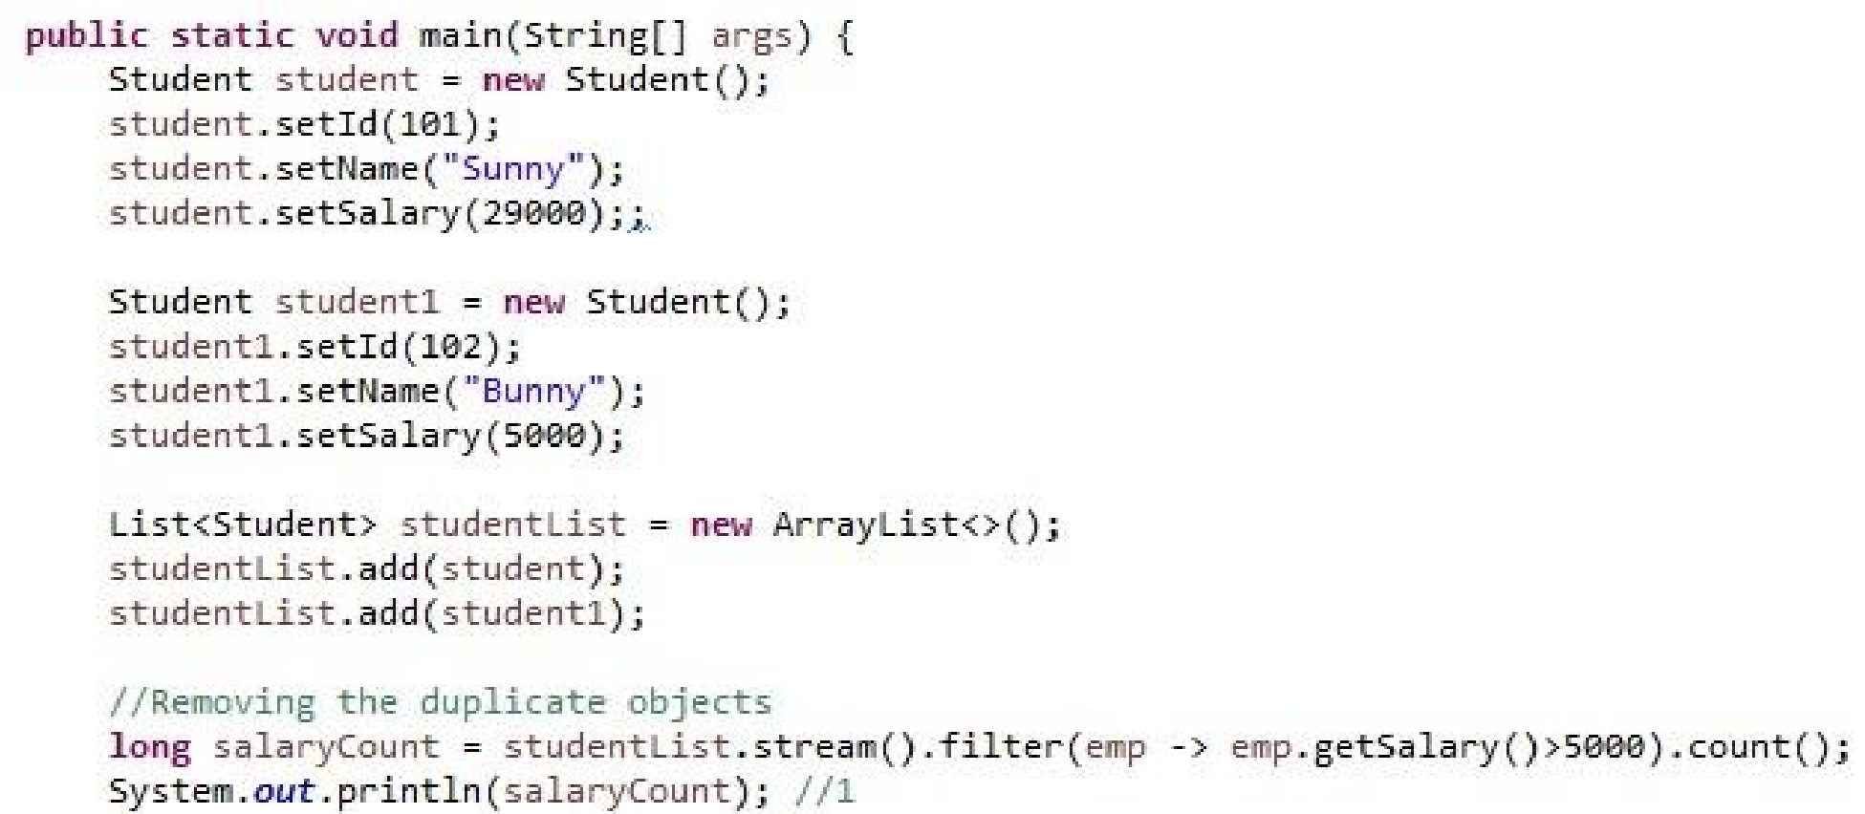

1. Given the list of employees, get the name of the employee with max and minimum salary?

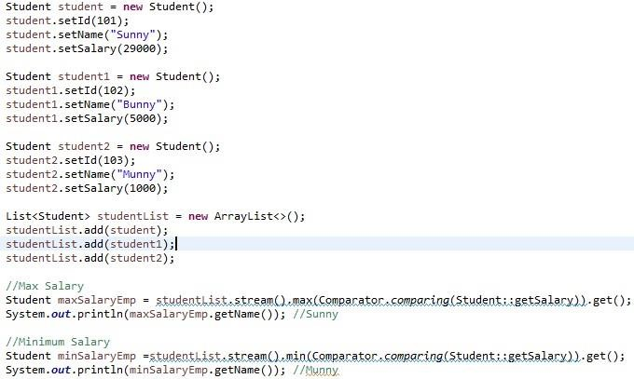

1. Write a logic to sort employee by his Name?

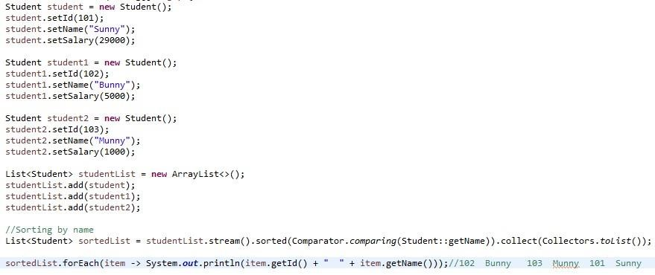

1. Given the list of employee, group them by employee name?

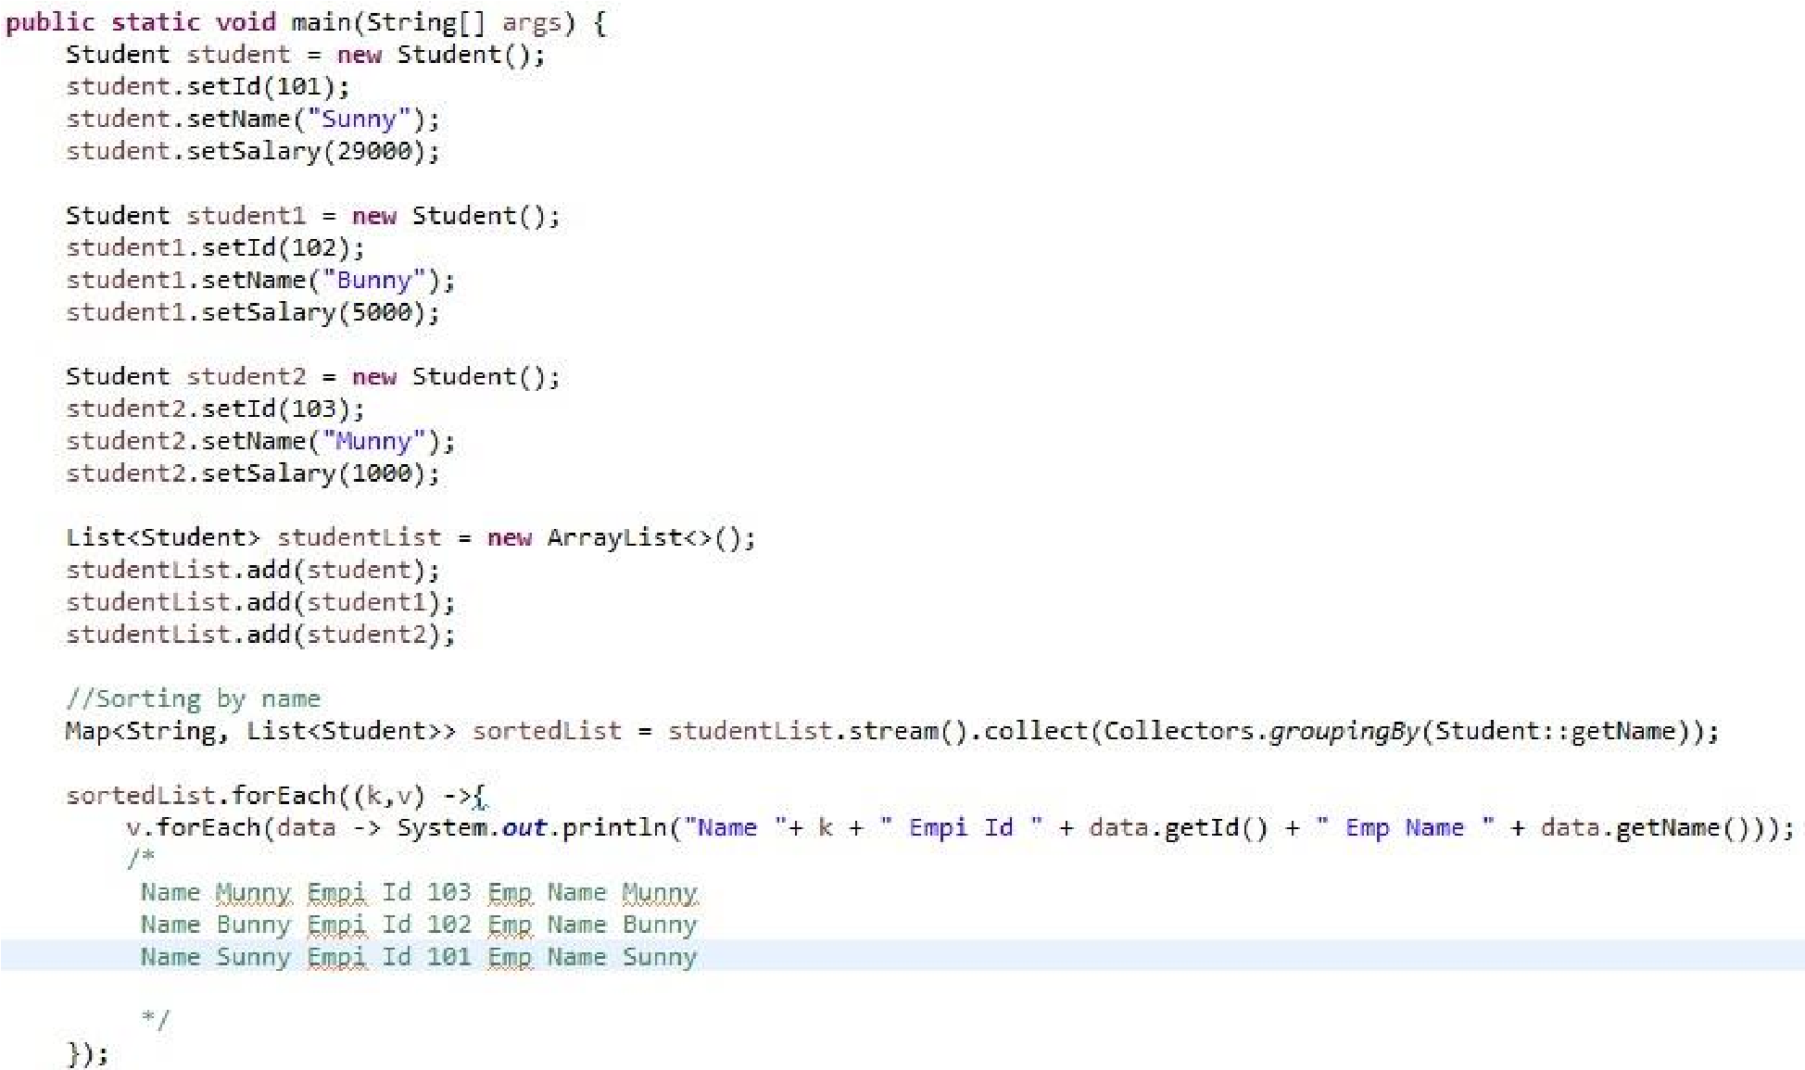

1. Write a program to display the employee details in list descending order?

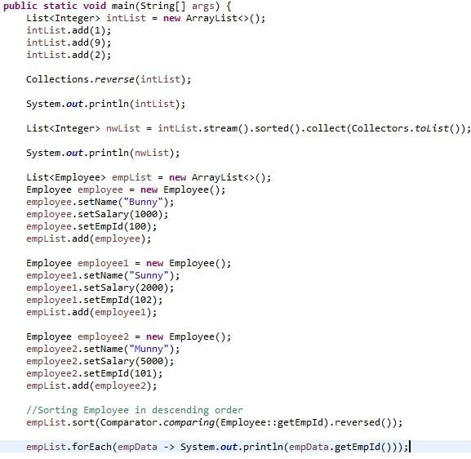

1. Write a program to display the employee details in map descending order?

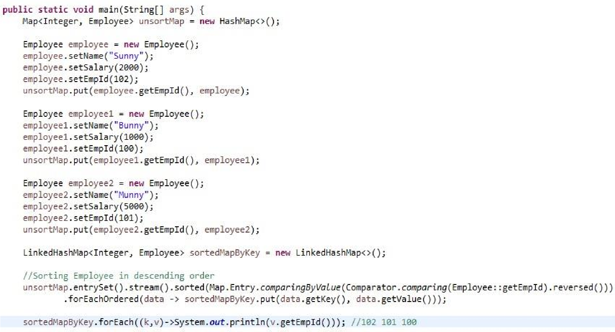

1. Write a program to implement your own HashMap?

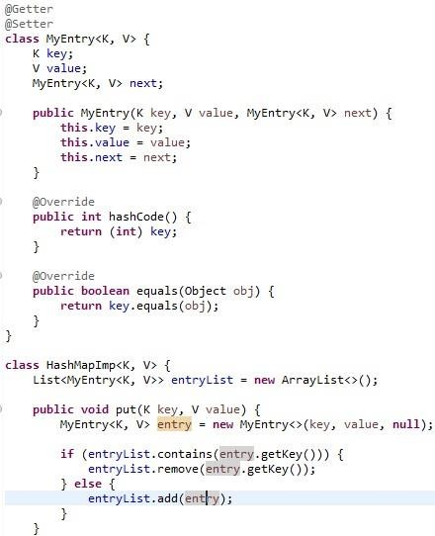

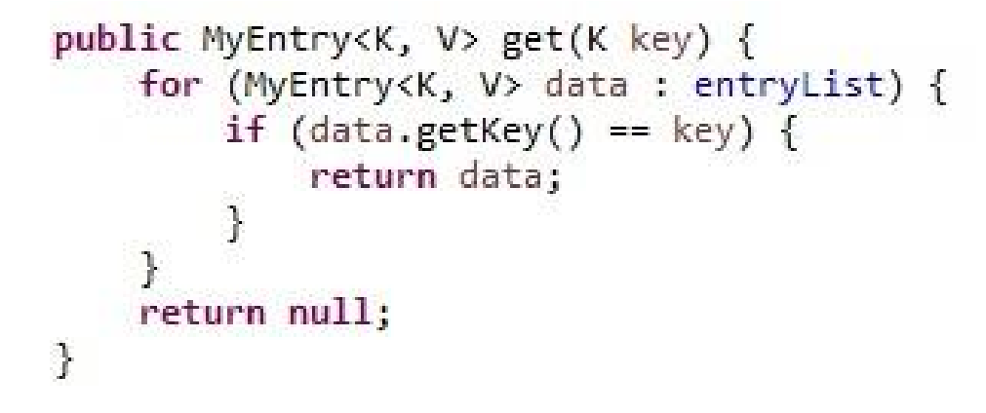

1. Write a logic to implement custom ArrayList?

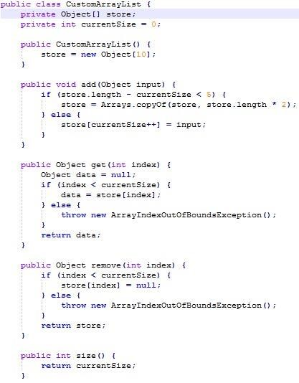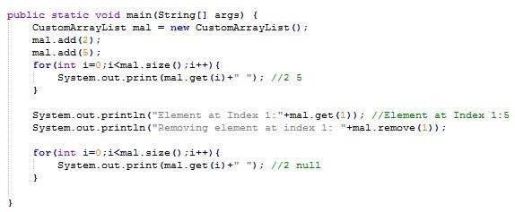

1. Write a logic for inter thread communication?

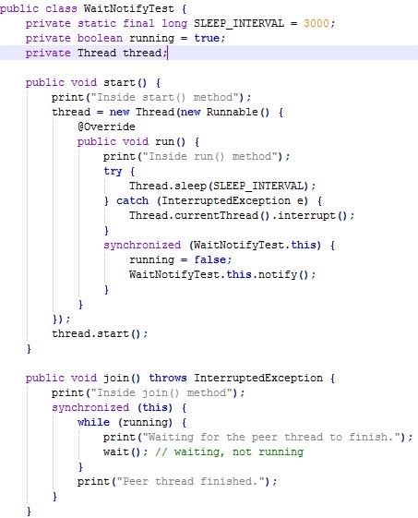

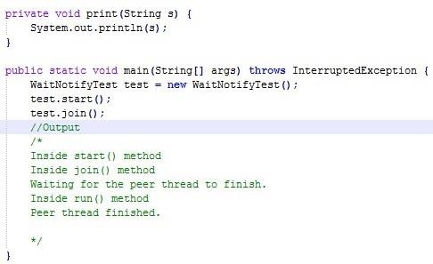

1. Write a java 8 program to count the repeated words in String?

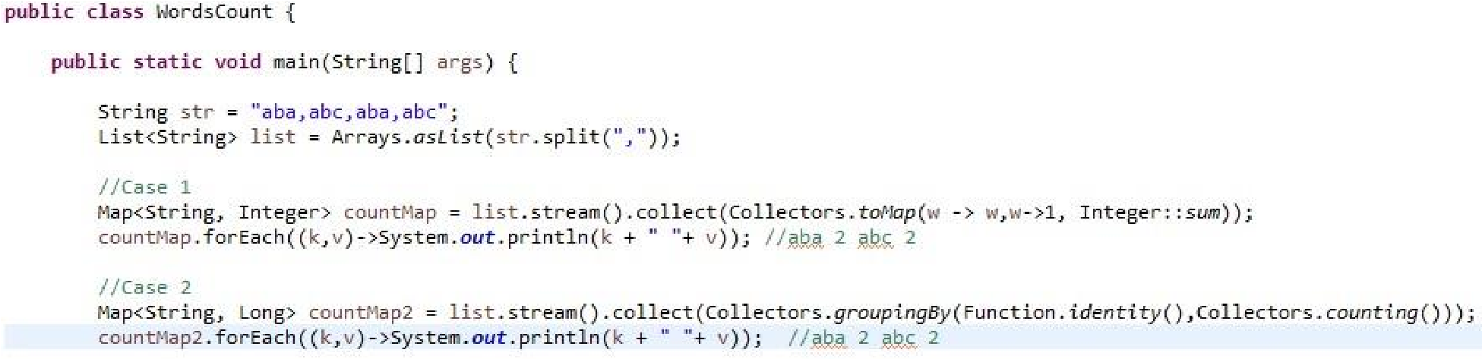

1. Given example for Singleton class that should not support multithreading access Deserialization, Clone, Reflection and overriding?

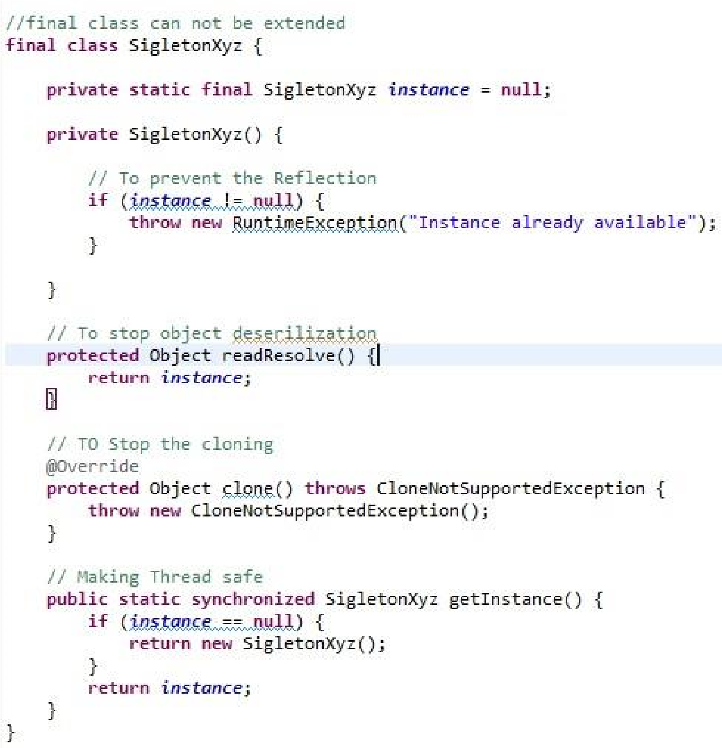

1. Write a java program to count the total number of occurrences of a given character in a string without using any loop?

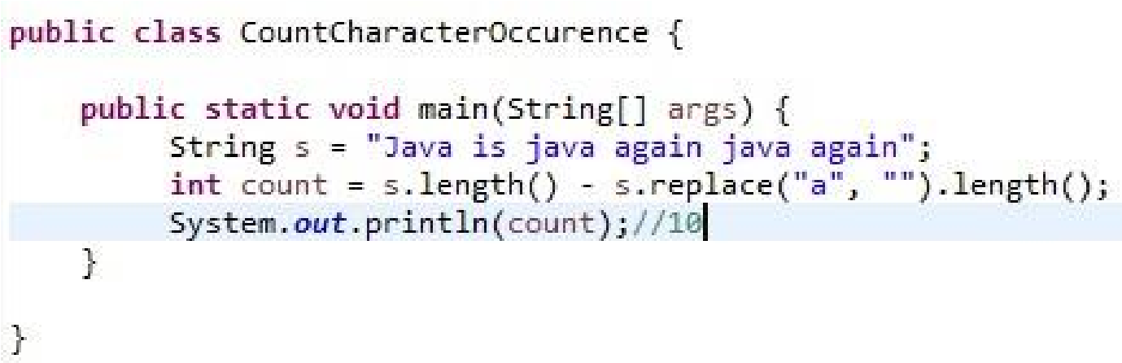

1. How to Reverse Each Word of a String in Java?

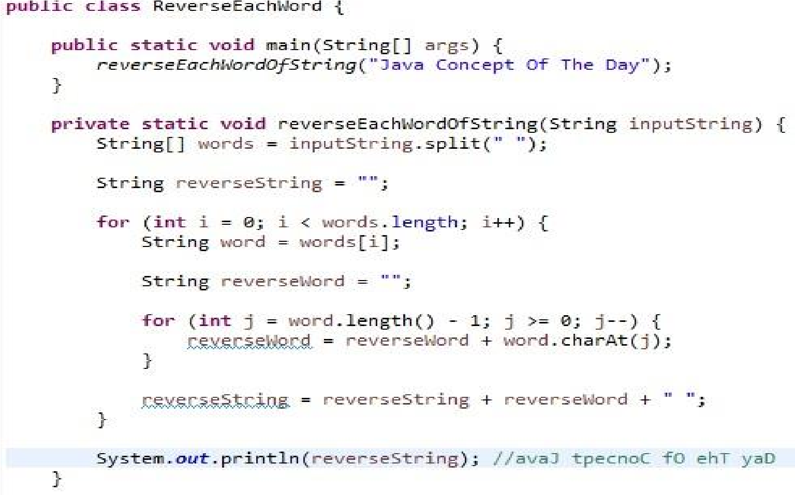

1. How to Reverse the String with Preserving the Position of Spaces?

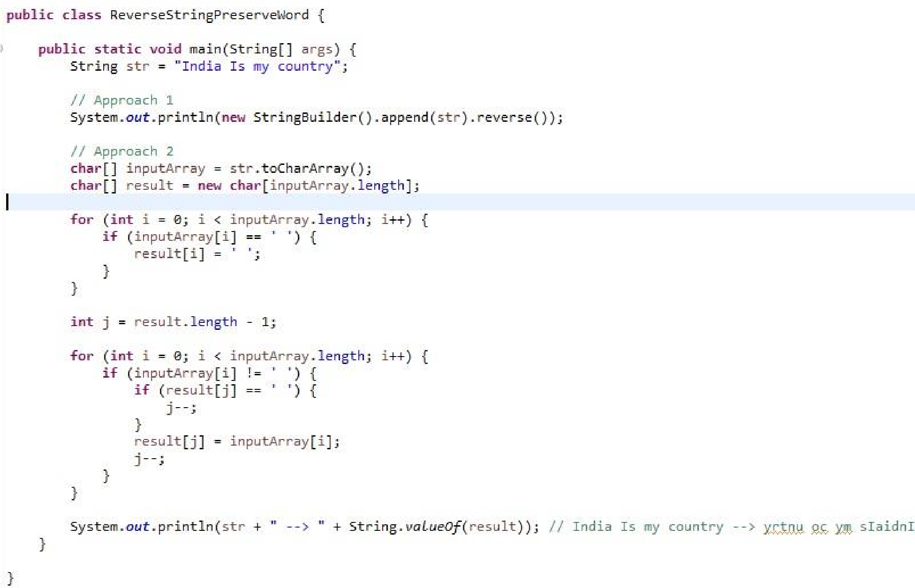

1. How to Find Longest Substring without Repeating Characters in Java?

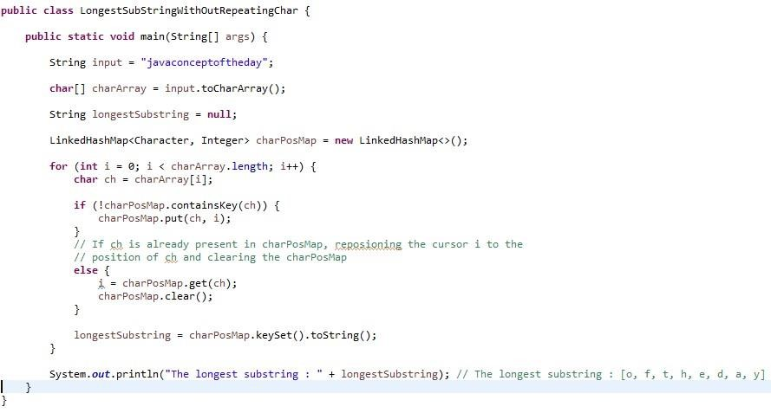

1. How to Find First Repeated and Non-Repeated Character in a String?

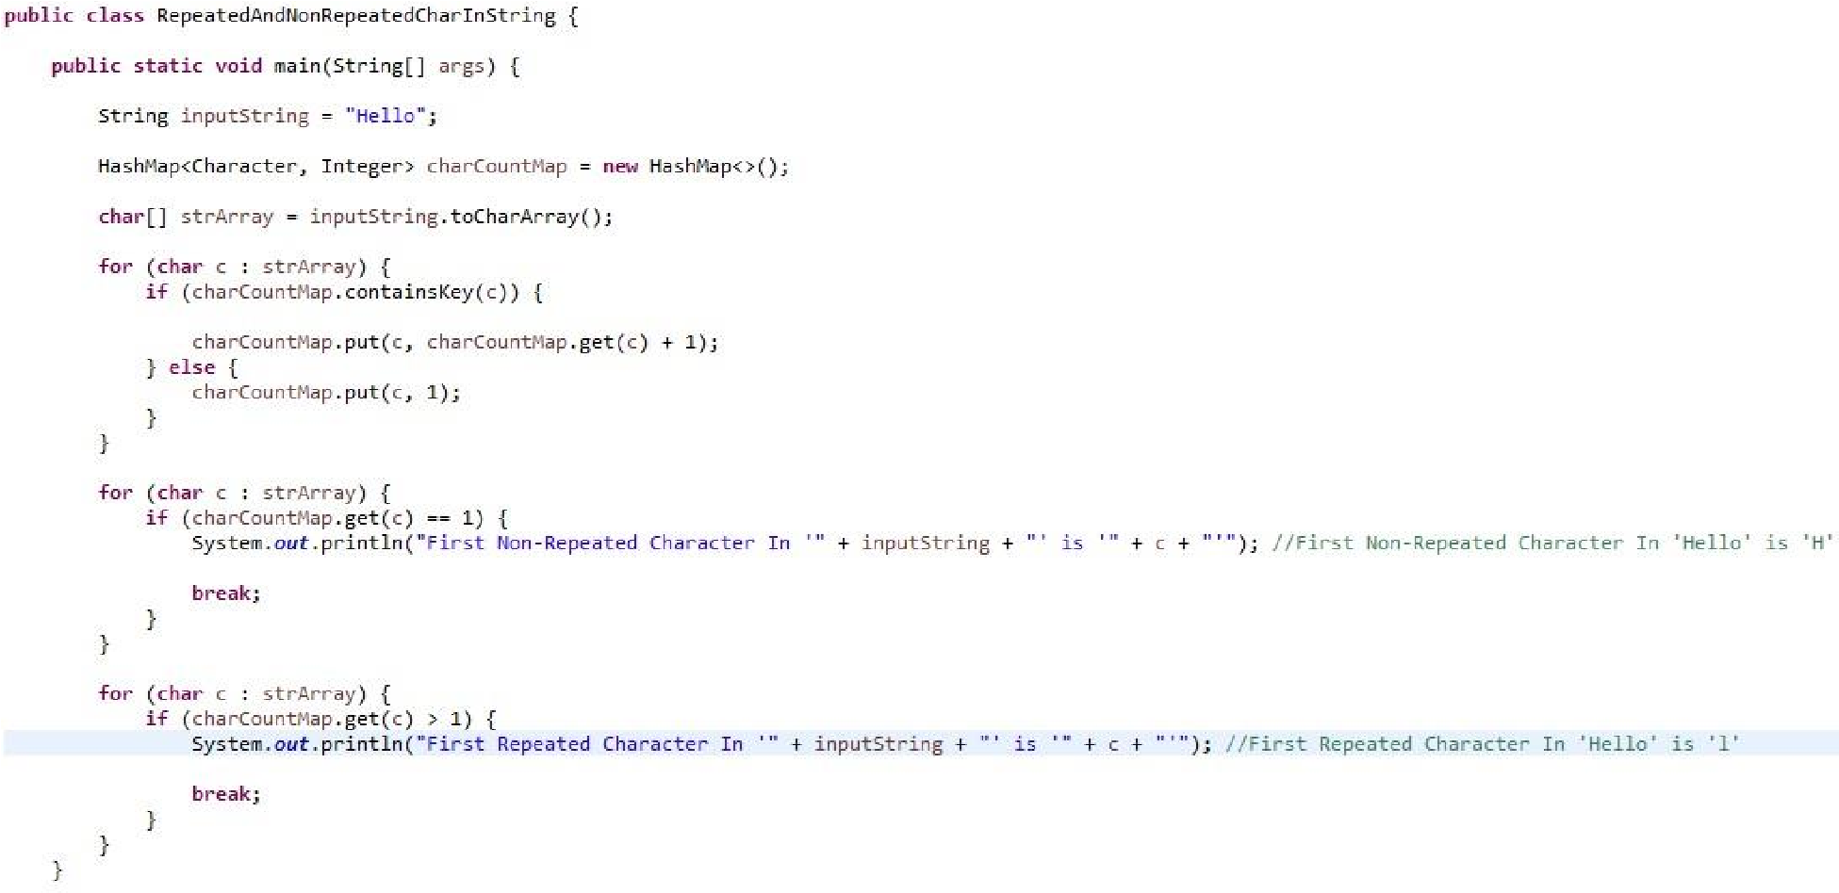

1. Write a java program to reverse an array without using an additional array?

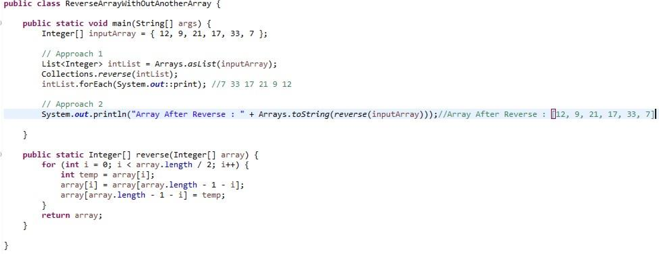

1. Write a java program to get the second highest number without sorting the array?

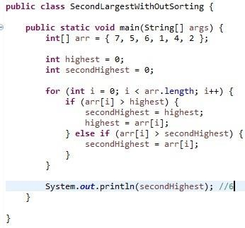

1. Write a program to implement immutable class with mutable fields?

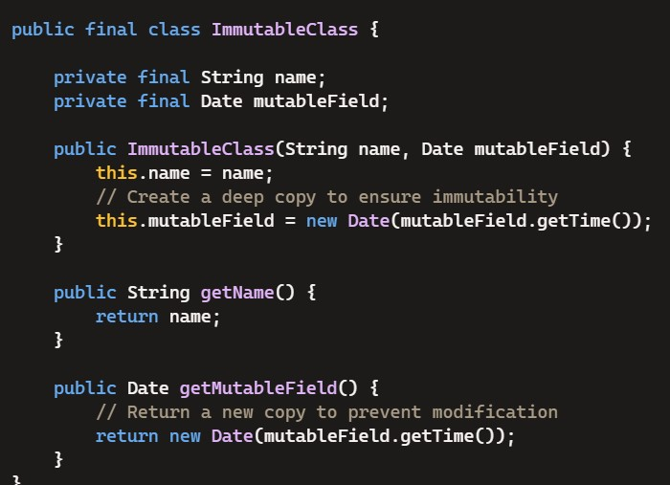

final Fields: Both name and mutableField are declared as final to ensure they are assigned once and do not change.

Deep Copy in Constructor: The constructor creates a new Date object using the Date(mutableField.getTime()) constructor to ensure the original Date object passed to it cannot be modified.

No Setter Methods: There are no methods provided to modify the fields.

Deep Copy in Getter: The getMutableField method returns a new Date object to prevent the internal mutableField from being modified by the caller.